Macromedia Contacts & Helpful Links 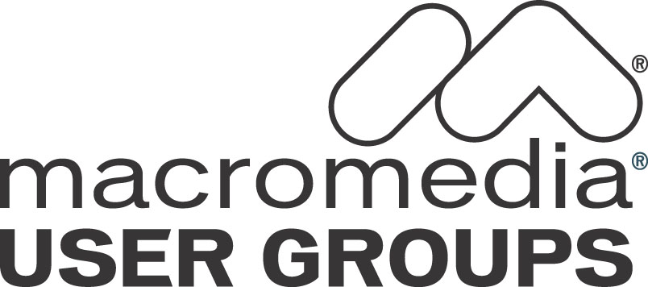

CONTENTS:
1. Contact Information
2. URL Resources
3. Blogs

1. Main Points of Contact:
User Group Program Head – Amy Brooks (abrooks@macromedia.com)

User Group Lead – Ed Sullivan (esullivan@macromedia.com)

Seminar Information – seminars@macromedia.com

Partner Information – partners@macromedia.com

2. URL Resources:
User Groups - http://www.macromedia.com/usergroups

DevNet - http://www.macromedia.com/devnet/

Events - http://www.macromedia.com/macromedia/events

Training/Certification - http://www.macromedia.com/support/training

Certification - http://www.macromedia.com/support/training/certified_professional_program

Customer Service - http://www.macromedia.com/support/email/cscontact/#

Macromedia Online Store - http://dynamic.macromedia.com/bin/MM/store/US/home.jsp

3. Related Blogs:
Mike Chambers' Blog
John Dowdell's Blog
Sean Corfield's Blog
Spike's Blog
Charlie Arehart's Blog
Matt Liotta's Blog
Web-Rat's Blog

